DS 620 Machine Learning and Deep Learning
HOS10Ab: RNN in PyTorch
03/1/2024 Reviewed by Sherin Aly
05/30/2024 Reviewed by Yogesh Goel
08/21/2025 Reviewed by Ashwin Paturi
11/19/2025 Reviewed by Kina Anh Bui

School of Technology & Computing (STC) @ City University of Seattle (CityU)

Before You Start
- The directory path shown in screenshots may be different from yours.
- The document uses Google Colaboratory as the default compiler. You need to configure the environment if you want to run the code on a local machine.
- Some steps are not explained in the tutorial. If you are not sure what to do:
  - Consult the resources listed below.
  - If you cannot solve the problem after a few tries, ask a TA for help.

Learning objectives
- RNN and LSTM

Resources
- Géron, A. (2019). Hands-on machine learning with scikit-learn, keras, and tensorflow (2nd ed.). O’Reilly Media.
- Loukas, S. (2020, July 10). Time-Series Forecasting: Predicting Stock Prices Using An LSTM Model. Towards Data Science. https://towardsdatascience.com/lstm-time-series-forecasting-predicting-stock-prices-using-an-lstm-model-6223e9644a2f

Introduction: Now that we’ve finished HOS10Aa, let’s implement the same networks using PyTorch as we did in TensorFlow.

Import Libraries
- Go to https://colab.research.google.com. Create a new notebook and name it “RNN_pytorch.ipynb”.
- Now, we need to import the necessary libraries. Type the following in your code cell, then click the play button or Ctrl + Enter to run the cell.
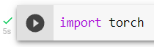
Data Preparation
- We’ll start by creating a random integer dataset and checking its shape. Click the + Code button to add new code cells. Please type the following code in the cells, then click the play button or Ctrl + Enter to run them.

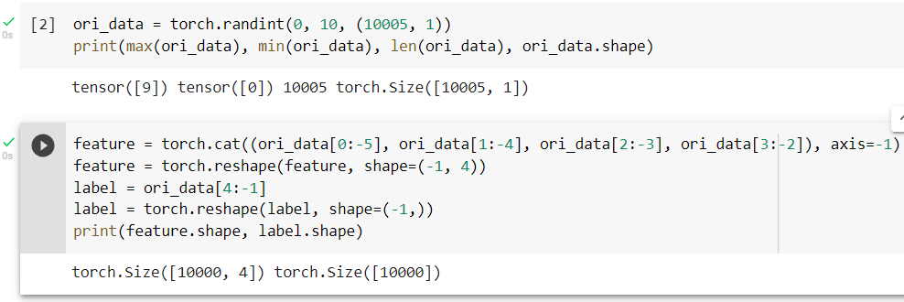

- Now, let’s encode the features and labels and divide the data into a training and testing set. Click the + Code button to add new code cells. Type the following code in the cells, then click the play button or Ctrl + Enter to run them.

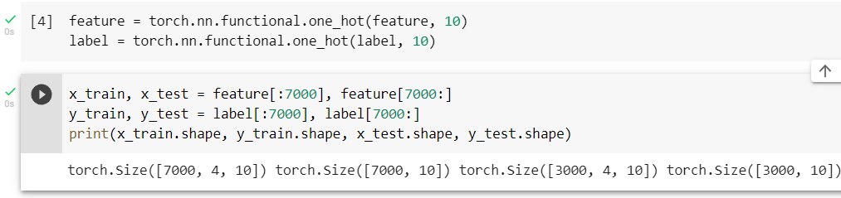

- Next, create a function that reads a batched data set. Click the + Code button to add a new code cell. Type the following code in the cell, then click the play button or Ctrl + Enter to run the cell.

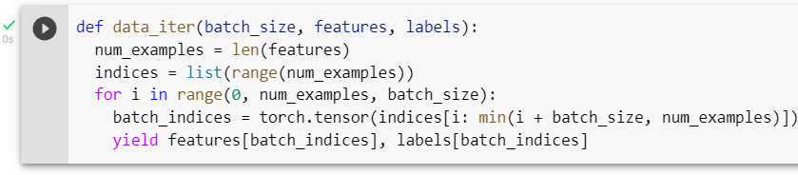

- Now, let’s test the function. Click the + Code button to add a new code cell. Type the following code in the cell, then click the play button or Ctrl + Enter to run the cell.
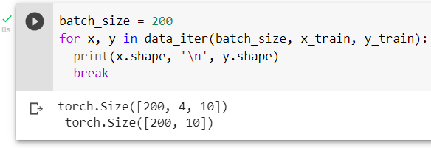

- Now, it’s time for the main focus of this exercise: creating the RNN. First, we will make the parameters in the RNN using a function. Click the + Code button to add new code cells. Type the following code in the cells, then click the play button or Ctrl + Enter to run them.

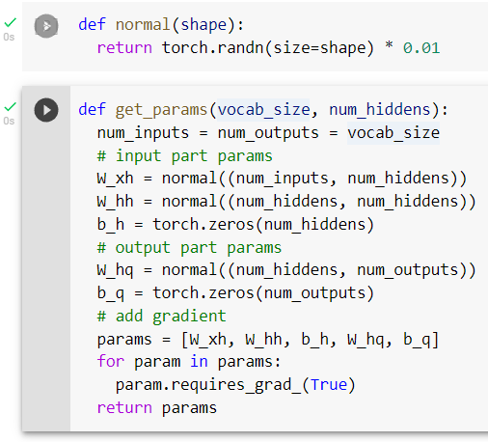

requires_grad_() lets PyTorch know these parameters are trainable. In TensorFlow, there are two kinds of tensors: constant and variable. The variable type means the tensor is trainable, and the constant type means the tensor is not. Therefore, we didn’t do the same operation in TensorFlow as we do now in PyTorch because the parameters tensor we created in TensorFlow was variable. In PyTorch, there is no classification of tensors. We have to make the parameter trainable by ourselves.

- Next, we’ll define the function initializing the yellow square. Click the + Code button to add a new code cell. Type the following code in the cell, then click the play button or Ctrl + Enter to run the cell.

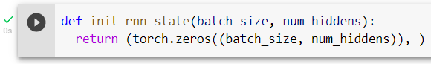

- We must also define the function used to execute the RNN process. Click the + Code button to add a new code cell. Type the following code in the cell, then click the play button or Ctrl + Enter to run the cell.

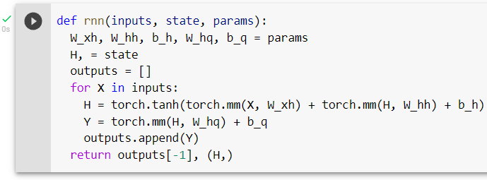

- Let’s define another function to calculate the accuracy. Click the + Code button to add a new code cell. Type the following code in the cell, then click the play button or Ctrl + Enter to run the cell.

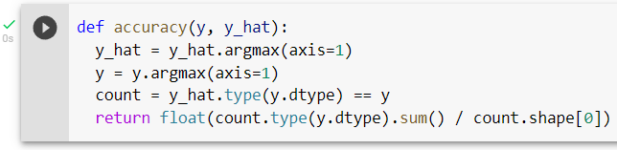

- Now, integrate the previous functions and create an RNN model. Click the + Code button to add new code cells. Please type the following code in the cells, then click the play button or Ctrl + Enter to run them.
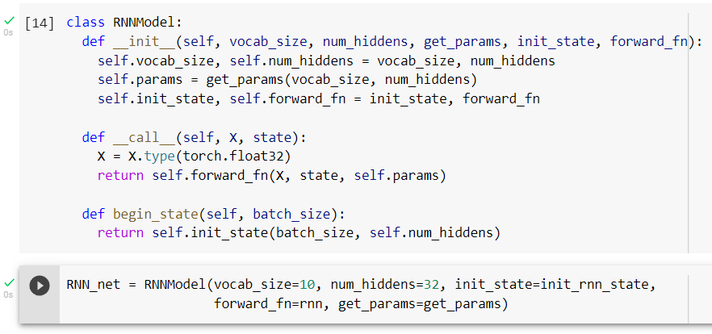

- We also need to set the loss function and optimizer. Click the + Code button to add a new code cell. Type the following code in the cell, then click the play button or Ctrl + Enter to run the cell.

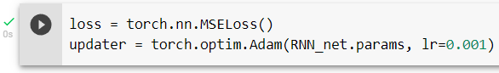

- Next, we’ll define a function to train the model. Click the + Code button to add a new code cell. Type the following code in the cell, then click the play button or Ctrl + Enter to run the cell.

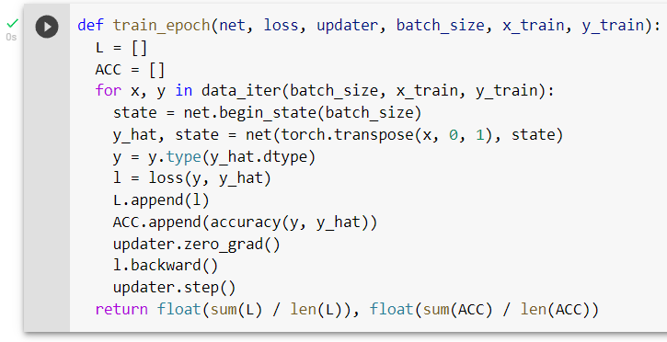

- Finally, let’s train 100 epochs. Click the + Code button to add new code cells. Type the following code in the cells, then click the play button or Ctrl + Enter to run them.

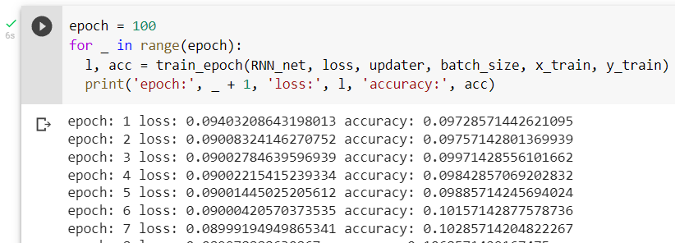
Note: This is only a snippet of the beginning of the output.

This model performs slightly better than the one we built in TensorFlow, but just barely. Its accuracy is roughly 14%, almost as bad as random chance, which would have a 10% accuracy.

- Let’s check the testing set. Click the + Code button to add a new code cell. Type the following code in the cell, then click the play button or Ctrl + Enter to run the cell.

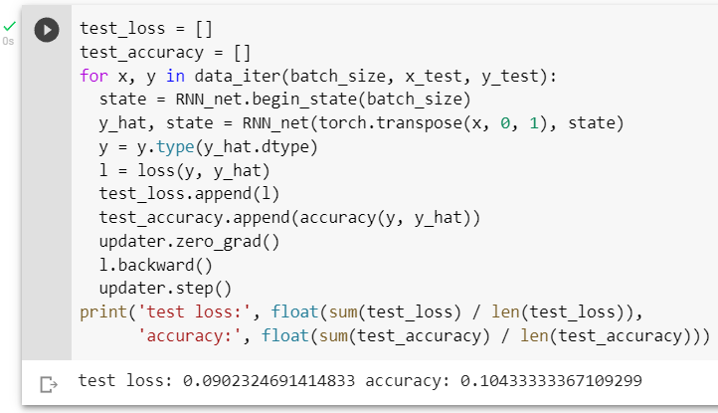

Again, the result is similar to the TensorFlow result. If you are interested, try changing the length of the training set to 100,000 or 1,000,000 and the input to 100 or 1,000 data simultaneously to predict the next one. (In this project, the training set shape is only 7000, 4, 10.)
Above, we explored creating an RNN model manually, but now let’s try using one directly from the PyTorch library.
- Let’s define the model, select the parameters, and determine the updater. Click the + Code button to add new code cells. Please type the following code in the cells, then click the play button or Ctrl + Enter to run them.

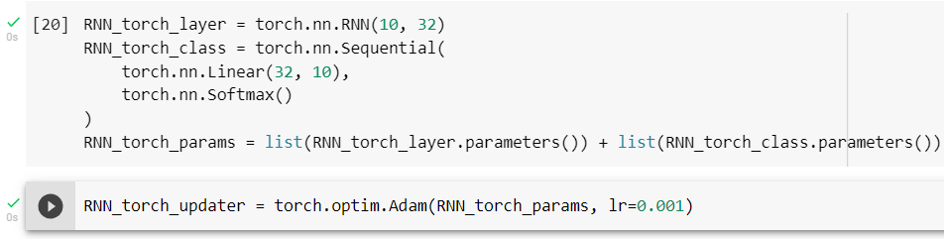

- Now, let’s train and evaluate the model. Click the + Code button to add a new code cell. Type the following code in the cell, then click the play button or Ctrl + Enter to run the cell.

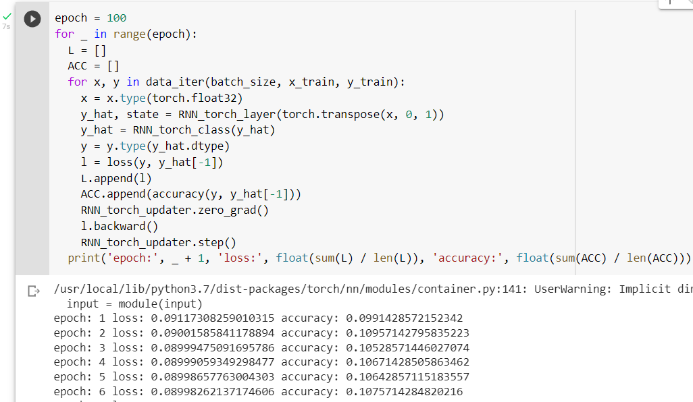
Note: This is only a snippet of the beginning of the output.

This result is similar to that of the RNN model we created and to our results in TensorFlow.

Long Short-Term Memory
- Let’s use the PyTorch library to create an LSTM model and define the updater. Click the + Code button to add new code cells. Please type the following code in the cells, then click the play button or Ctrl + Enter to run them.
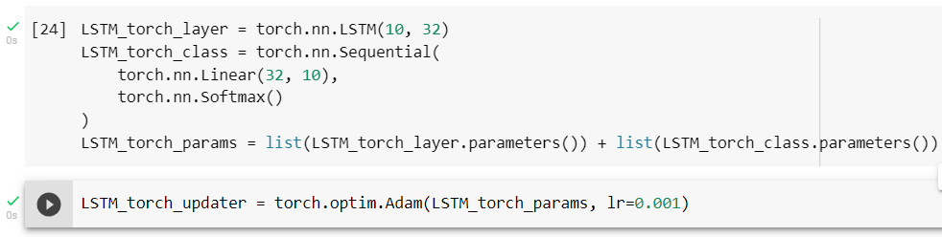

- Now, let’s train and evaluate the model. Click the + Code button to add a new code cell. Type the following code in the cell, then click the play button or Ctrl + Enter to run the cell.

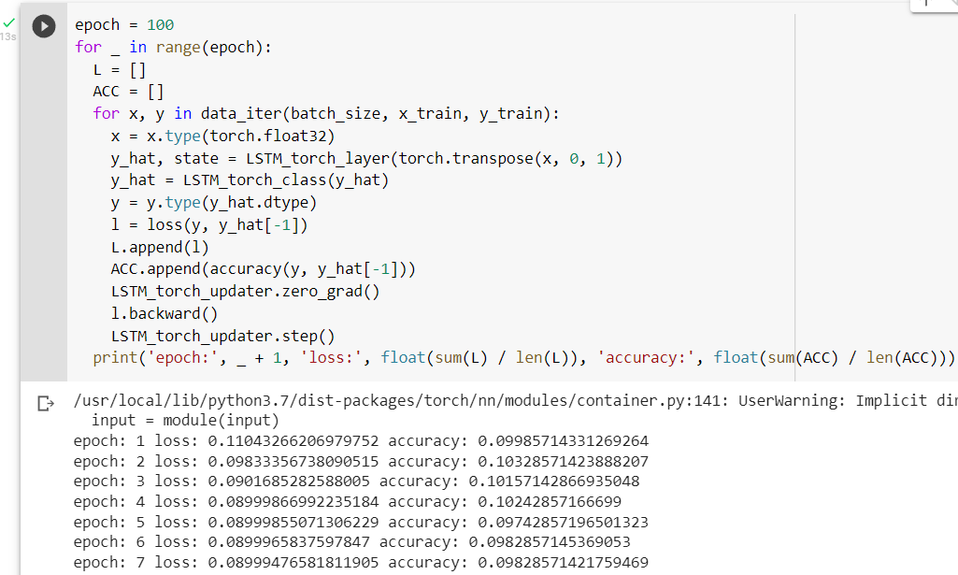
Note: This is only a snippet of the beginning of the output.

The result is similar to that of the other networks, as expected. As mentioned before, LSTM works better if the time series is long.

Push your work to GitHub:
Click File → Download → Download .ipynb.
The file will be downloaded to your Download folder (or another folder according to your browser settings).
Move the downloaded ipynb file to your Module 10 folder.
Follow the instructions on the CityU STC TA Center Github.io. Submit your work page.

